

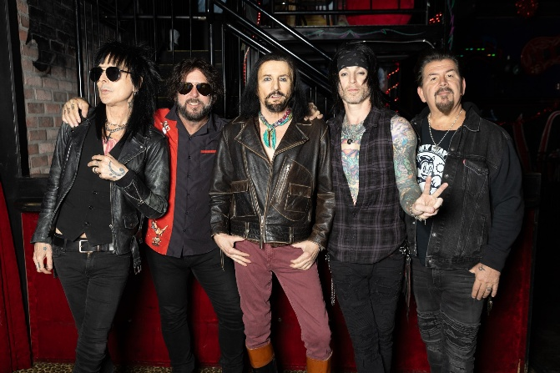

**AFTER 40 YEARS, L.A. GUNS**

**ARE STILL GRINDING WITH A**

**NEW ALBUM, ‘LEOPARD SKIN,’ OUT APRIL 4**

**ON CLEOPATRA RECORDS**

**FIRST SINGLE/VIDEO, “TASTE IT,” OUT NOW**

**TOUR SET TO LAUNCH APRIL 22**

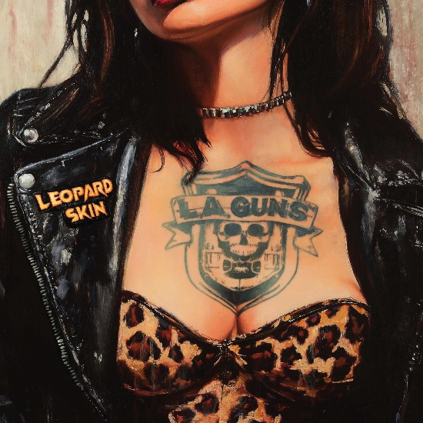

February 6, 2025 -- It was almost 40 years ago that **L.A. Guns** established themselves as the undisputed sleaze kings of the Sunset Strip, and, eventually, the world. At this point in time, most bands in their position would be content to lay back, rest on their rock ‘n’ roll laurels and trot out the hits on endless repeat for the fans.

Instead, L.A. Guns, in true down ‘n’ dirty form, are grinding with the April 4 release of their 15th studio album, LEOPARD SKIN, on Cleopatra Records. The mouthwatering first single, “Taste It,” was released today on all [digital outlets](https://orcd.co/laguns_tasteit). Pre-orders for the album are available now on all digital outlets [here](https://orcd.co/laguns_leopardskin), CD/vinyl pre-orders available [here](https://cleorecs.com/search?q=l.a.+guns+leopard+skin), and the Jason Wisch-directed video can be found on Cleopatra Records’ official [YouTube page](https://youtu.be/6Lj3pD7H5rM).

“There’s the saying, ‘a leopard never changes its spots,’” founding guitarist Tracii Guns says. “But even so, they have a million different spots. And they’re all unique. It’s the same with L.A. Guns. We can’t shed our leopard skin, but there’s a lot of different spots in this band.”

Those spots run the gamut from early anthems like “Electric Gypsy,” “Rip and Tear” and “Over the Edge,” to indelible ballads like “It’s Over Now” and “The Ballad of Jayne,” to more recent classics like “Speed,” “Cannonball” and now, the ten tracks that comprise the new album.

Not only is LEOPARD SKIN hot on the heels of 2023’s BLACK DIAMONDS album, but is also their fifth studio effort in seven years, since the core team of guitarist and band founder Tracii Guns and singer Phil Lewis reunited in 2017. LEOPARD SKIN, like the last few L.A. Guns records, reconvenes the tight-knit lineup of Guns, Lewis, bassist Johnny Martin, guitarist Ace Von Johnson and studio drummer Adam Hamilton, but beyond that it is its own unique beast. True to form, it’s a hard-and-heavy, tough-as-nails L.A. Guns set. But the music also presents the band at their funkiest, rowdiest, most classic-rock-worshipping best. And it’s clear they’re having a helluva lot of fun playing it.

Explains Tracii, “When we started doing records again in 2017, I wanted to be really aggressive. We hadn't put out anything new in a lot of years, and we needed to be focused to have an impact. This one was a different approach. Musically, it was more about James Brown and soul music, with some ’70s sensibilities – things like Joe Walsh and the Rolling Stones and the New York Dolls. And the process was more organic. It was, ‘Here’s a riff, go for it. Let's see how many riffs we can build after this riff, and then going into the next riff.’”

The results speak for themselves. You want a four-on-the-floor AC/DC-style stomper? Cue up anthemic opener “Taste It.” Slippery funk-rock? Try out “Lucky Motherfucker” or “Don’t Gimme Away.” Rollicking ‘70s-style glam? Drop the needle on “If You Wanna.” Swampy, slide guitar-laced grooves? Crank up the Zep-tastic “The Grinder.”

Where does that position L.A. Guns in 2025? Tracii returns to LEOPARD SKIN. “The song title ‘Lucky Motherfucker’ kinda says it all,” he says. “Because I don't know how many other bands that have been around almost 40 years are still out there not just touring consistently, but putting out records consistently, and the thing just keeps getting bigger and bigger from year to year.”

He continues. “So the work ethic is yielding what it’s supposed to, you know what I mean? The fans stay excited, we stay excited, and we keep making records. And as long as we have that opportunity and there’s a place for this music in the world, there’s no reason to ever stop.”

Here’s the track listing for LEOPARD SKIN:

1. Taste It

2. Lucky Motherfucker

3. The Grinder

4. Hit and Run

5. Don’t Gimme Away

6. I’m Your Candy Man

7. Runaway Train

8. Following the Money

9. The Masquerade

10. If You Wanna

Check out L.A. Guns at any of the following tour stops:

**DATE CITY VENUE**

3/10 – 3/15 Miami, FL Monsters of Rock Cruise

Tue 4/22 Warrendale, PA Jergels

Wed 4/23 N. Tonawanda, NY Riviera Theatre

Fri 4/25 Derry, NH Tupelo Music Hall

Sat 4/26 New Bedford, MA The Vault Music Hall

Sun 4/27 Millersville, PA Phantom Power

Tue 4/29 Annapolis, MD Rams Head on Stage

Wed 4/30 Ardmore, PA The Ardmore Music Hall

Thu 5/1 Leesburg, VA Tally Ho Theater

Fri 5/2 Hopewell, VA The Beacon Theatre

Sun 5/4 Virginia Beach, VA Elevation 27

Tue 5/6 Atlanta, GA City Winery Atlanta

Fri 5/9 Fort Myers, FL Buddha Live

Sat 5/10 Dania Beach, FL The Casino’s Stage 954 @ Dania Beach Entertainment Center

Sun 5/11 Mount Dora, FL Mount Dora Music Hall

Tue 5/13 Largo, FL Central Park Performing Arts Center

Thu 5/15 Jefferson, LA Southport Music Hall

Fri 5/16 Cedar Park, TX The Haute Spot

Sat 5/17 Dallas, TX Granada Theater

Sun 5/18 Houston, TX Warehouse Live Midtown

Fri 5/23 Omaha, NE Barnato

Sat 5/24 Denver, CO The Oriental Theater

Fri 7/18 West Hollywood, CA Whisky a Go Go

Sat 7/19 West Hollywood, CA Whisky a Go Go

Sat 7/26 Beaver Dam, KY Beaver Dam Amphitheater

[Website](http://www.lagunsmusic.com/)

[Facebook](https://www.facebook.com/L.A.GunsOfficial)

[Instagram](https://www.instagram.com/laguns)

[YouTube](https://www.youtube.com/channel/UCH1hyfg5p7TObQnr-IxzqJA)

###

CONTACTS:

Amanda Cagan

ABC Public Relations

[amanda@abc-pr.com](mailto:amanda@abc-pr.com)